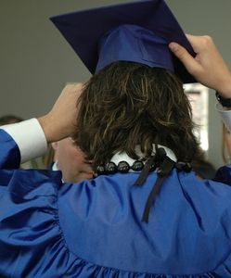

**Class of 2020 Service Project**

**Overview**

*Students in all grades benefit from participating in service learning projects.*

*Many schools today provide service learning experiences for students integrated with their classwork. The service learning projects allow students to make a difference in their community while building social, civic, and academic skills. Social skills are improved because many projects are collaborative and students must work together and with a broad range of people outside the academic arena. Civic skills are strengthened as students work toward the common good. Academic skills are strengthened because academic content becomes more relevant and practical as students use their classroom learning. Students also learn higher-order skills, such as project development and management.*

*As a part of Hamlin’s 8th grade graduation requirements, we are asking that all students complete a service project. This can be in conjunction with NJHS, Confirmation, and/or any other groups that they are in. A* ***minimum of 10 hours*** *needs to be documented. We will accept hours from the summer of 2019 as long as* ***you did not earn money*** *from said service hours. Some examples include:*

* *Shoveling snow for the neighbors*
* *Cleaning up trash around the neighborhood*
* *Helping out at an Animal Shelter, Children’s Hospital, Senior Citizen Home,..etc*
* *Recycling drives, beautification projects, tutoring after school,..etc*

*Do not include babysitting or helping a sibling as a service project. The ideas are endless so let’s get started on a project to help our communities! See reverse side for service hour documentation forms and specific details. Hours are due by March 13, 2020.*

*Let’s get creative!*

*Ms. Doig*

***8th Grade Service Project Hours Log***

*Activities must be verified by neighbors, teachers, coaches, sponsors, parents, someone affiliated with the organization listed. A minimum of* **10** *hours is required by March 13th.*

|  |  |  |  |
| --- | --- | --- | --- |
| Description of Activity | Date | # of Hours | Signature/Phone # of Adult Sponsor |
|  |  |  |  |
|  |  |  |  |
|  |  |  |  |
|  |  |  |  |
|  |  |  |  |
|  |  |  |  |
|  |  |  |  |

*Student Name: _____________________________ Class of 2020*